CHAPTER ONE

INTRODUCTION

1.1 Introduction
In the contemporary global landscape, the integration of Information and Communication Technology (ICT) has become a fundamental driver of efficiency, accuracy, and structural transformation across institutional sectors. Within the ecosystem of modern healthcare delivery, the management of data stands as one of the most critical operational challenges. Hospitals and medical clinics generate vast, continuous streams of complex information daily encompassing patient demographic profiles, clinical triage records, diagnostic lab reports, pharmaceutical inventories, and complex financial billing cycles.
To transform this massive data flow into actionable, secure, and highly efficient medical workflows, healthcare institutions are increasingly transitioning away from legacy workflows toward automated web-based systems. A web-based Hospital Management System (HMS) serves as an enterprise-grade digital solution designed to centralize, manage, and optimize the clinical, administrative, and financial pillars of a healthcare facility. By deploying a structural interface accessible through secure web protocols, an HMS aims to create a cohesive digital bridge connecting receptionists, nursing staff, medical officers, laboratory technicians, pharmacists, and administrative accountants into a single, unified database environment.

1.2 Background to the Study
Historically, healthcare institutions within developing infrastructural frameworks, notably regional and district-level medical facilities in Cameroon, have relied heavily on manual, paper-based ledger systems to document and manage patient lifecycles. Under these traditional frameworks, a patient’s medical history is physically recorded on paper cards, filed in manual archive rooms, and manually ferried across distinct physical departments as the patient moves from the registration desk to triage, consultation, testing, and finally the pharmacy.
While paper systems served baseline operational needs in periods of low patient traffic, the rapid growth of urban and semi-urban populations has pushed manual systems to their breaking point. Literature focusing on medical informatics consistently demonstrates that paper archives create significant operational friction, leading to severe delays in data retrieval, high risks of physical document destruction, and structural fragmentation where individual departments operate as isolated data silos.
The emergence of modern web computing architectures specifically utilizing responsive front-end frameworks running over secure relational database backends offers a scalable solution to these institutional challenges. Web-based architectures eliminate the need for costly client-side software installations at every individual hospital terminal; instead, the entire system can be securely hosted, updated, and accessed uniformly via local web browsers. Consequently, this study leverages modern web development stacks to design, implement, and evaluate an integrated Hospital Management System structured to meet the localized workflows and resource demands of regional medical facilities.

1.3 Statement of the Problem
Despite the clear operational advancements offered by digital technology, the baseline reality within many regional healthcare facilities remains dominated by inefficient manual processes. This reliance on paper-based ledger systems creates critical institutional vulnerabilities that directly compromise both administrative efficiency and the overall quality of patient care:
- Severe Information Retrieval Delays and Queue Congestion: Under manual systems, returning patients experience prolonged waiting times at the registration desk while staff physically search through thousands of paper folders, directly leading to severe clinic congestion.
- High Rates of Clinical and Data Entry Errors: Illegible medical handwriting on paper prescription slips frequently leads to dangerous misinterpretations in the pharmacy, while manual transcription of laboratory results across multiple paper registers introduces high rates of typographical errors.
- Financial Leakage and Inaccurate Billing: Because the financial desk relies on physical, hand-written tallies compiled across distinct clinical, laboratory, and pharmacy stations, the hospital suffers from significant revenue leakage due to unbilled services, lost receipts, and manual calculation errors.
- Lack of Real-Time Data Synchronization: Because information cannot move instantly between physical departments, medical officers are frequently forced to make critical clinical decisions without immediate, real-time access to a patient’s updated laboratory outcomes or pharmaceutical compliance history.
- Data Vulnerability and Lack of Access Control: Physical paper folders possess no built-in security features, making patient medical histories vulnerable to unauthorized access, loss, or total destruction from physical hazards like fires or water damage.
Without a centralized, automated web interface running over a normalized relational database, these operational bottlenecks will continue to restrict hospital capacity, inflate administrative overhead, and compromise data security. This project directly addresses these systemic vulnerabilities by building a secure, role-based, integrated web platform engineered to eliminate paper dependencies and unify the clinical lifecycle.

1.4. Objectives of the Study

1.4.1. General Objective
The general objective of this project is to design and implement an integrated, web-based Hospital Management System (HMS) that automates core clinical, administrative, and financial workflows, thereby eliminating manual paper dependencies, reducing operational bottlenecks, and improving data integrity and security within a regional healthcare environment.

1.4.2. Specific Objectives
To achieve the general objective, the following specific objectives will be executed:
- To analyze and map the existing manual patient workflows and architectural bottlenecks within the case study hospital to establish comprehensive functional and non-functional system requirements.
- To design a secure, normalized relational database schema and a Three-Tier software architecture that seamlessly unifies registration, triage, consultation, laboratory, pharmacy, and billing operations.
- To implement the web-based application using a responsive frontend interface coupled with a structured backend execution engine and an open-source database platform.
- To integrate a rigid Role-Based Access Control (RBAC) security framework to enforce data confidentiality and restrict system privileges based on explicit staff designations.
- To evaluate the developed system prototype through structured User Acceptance Testing (UAT) to measure usability, transaction speed, functional completeness, and overall operational fit.

1.5. Significance of the Study
The realization of this project provides substantial, multi-dimensional benefits across institutional, clinical, administrative, and academic domains:
- Institutional and Operational Efficiency: The hospital management benefits from automated, real-time data synchronization across all physical wings, significantly accelerating patient throughput times and lowering overhead costs associated with physical file procurement and storage.
- Clinical Precision and Data Integrity: Medical officers and nursing staff gain immediate, secure access to comprehensive electronic health records, eliminating clinical errors driven by illegible handwriting and preventing data fragmentation across department registries.
- Financial Accountability: The administration and finance department benefits from the automated compilement of service items, completely blocking manual calculation errors and eliminating revenue leakage through automated billing tracking.
- Academic Contribution: For the discipline of Software Engineering, this study provides a practical, fully documented architectural framework detailing how localized workflow constraints in developing healthcare infrastructures can be solved using open-source, scalable web stacks.

1.6. Scope of the Study
The boundary configurations of this research project are defined along the following specific dimensions:
- Functional Scope: The software system strictly encompasses six core interconnected modules: Patient Registration (Demographics), Nursing Triage (Vitals Capture), Medical Officer Consultation (Clinical Notes/EHR), Laboratory Management (Test Requests/Results Payload), Pharmacy Management (Stock Control/Dispensing Status), and Finance/Billing Management (Invoice Generation/Payment Status).
- Technical Scope: The implementation is bounded by standard web browser compatibility, utilizing open-source structural backend tools, relational database management systems, and web scripting components to ensure local deployment viability without expensive proprietary licensing.
- Security Scope: System security is intentionally restricted to local authentication protocols, role-based database view limits, and automated server-side request verification. It excludes external telecommunication payment integrations or federated cloud authentication frameworks.

1.7. Definition of Terms
- Hospital Management System (HMS): An integrated, enterprise-grade software platform engineered to centralize, manage, and optimize the clinical, administrative, and financial workflows of a healthcare facility.
- Electronic Health Record (EHR): A secure, dynamic, and digital compilation of a patient’s medical history, clinical encounter notes, vital signs, lab results, and pharmaceutical prescriptions maintained over time.
- Role-Based Access Control (RBAC): A rigid system security mechanism that restricts data visibility and transaction execution rights strictly based on the defined administrative or clinical role of the authenticated user.
- Three-Tier Architecture: A software design pattern that decouples an application into three distinct logical layers: the Presentation Layer (User Interface), the Application Layer (Business Logic), and the Data Layer (Database Management).

1.8. Organization of the Study
This project report is systematically organized into five distinct chapters to maintain a logical and professional research progression:
- Chapter One (Introduction): Outlines the structural foundation of the study, detailing the background of medical digitization, defining the core manual operational problems, and framing the guiding objectives, scope, and significance of the project.
- Chapter Two (Literature Review): Conducts a comprehensive technical and theoretical exploration of key informatics concepts, reviewing requirements analysis methodologies, database normalization frameworks, security protocols, and web technology stacks.
- Chapter Three (Materials and Methods): Explains the structural research design, detailing the study population, sample configuration, data collection techniques, system analysis modeling workflows, and strict ethical considerations.
- Chapter Four (Results): Presents the concrete engineering outputs of the project, detailing the mapped requirements, the normalized relational database models, architectural diagrams, physical technology implementations, and the quantitative data derived from User Acceptance Testing.
- Chapter Five (Discussion, Conclusions, and Recommendations): Contextualizes the project findings against existing medical computing literature, evaluates the research hypotheses, states core conclusions, and outlines actionable recommendations for deployment and future architectural expansion.

CHAPTER TWO

LITERATURE REVIEW

2.1. Introduction
The development of enterprise-grade clinical software requires a solid understanding of both theoretical computing frameworks and existing practical applications. This chapter provides a comprehensive review of the concepts, architectural patterns, and security frameworks that form the foundation of a modern web-based Hospital Management System (HMS).
First, it establishes a conceptual framework by exploring the core pillars of health informatics, data centralization, and multi-tier system designs. Next, it analyzes five relevant contemporary software systems, highlighting their technology stacks, core strengths, and structural limitations. Finally, this chapter outlines the proposed solution, detailing the system architecture designed to address the manual operational bottlenecks identified in Chapter One.

2.2. Review of Related Concepts or Conceptual Framework

2.2.1. Web-Based Information Systems and Three-Tier Architecture
Modern enterprise web applications widely deploy a Three-Tier Architecture to isolate systemic responsibilities and protect database stability. This structural paradigm divides the platform into three independent layers:
- Presentation Layer (Frontend): The user interface built using responsive layouts (HTML5/CSS3/JavaScript) that runs inside standard web browsers, ensuring staff can access the system without local client installations.
- Application Layer (Backend Logic): The engine (implemented via server-side frameworks like PHP) that processes business rules, validates user requests, and coordinates data movement between departments.
- Data Layer (Database Engine): The underlying storage engine (such as MySQL) responsible for executing structured queries, enforcing primary/foreign key relationships, and ensuring high data durability.

2.2.2. Relational Database Normalization and Data Integrity
In a multi-departmental clinic setup, data consistency across registration, testing, and billing is critical. To prevent duplicate entries and data anomalies, databases must be strictly normalized up to the Third Normal Form (3NF). Normalization splits data into distinct, clean entities (e.g., separating patient profiles from individual clinical encounters), ensuring that updates to a patient’s record update uniformly across all departments without affecting historical billing transactions.

2.2.3. Role-Based Access Control (RBAC) and Medical Data Security
Because medical data is highly sensitive, applications must use an explicit Role-Based Access Control (RBAC) security model. RBAC secures data by restricting access permissions based on a user's authenticated role:
- Receptionists are restricted to patient registration inputs and cannot view clinical treatment files.
- Nurses can input vital signs but cannot write official prescriptions or alter invoice records.
- Medical Officers (Doctors) hold read/write access to clinical profiles and lab requests but cannot modify inventory pricing tables.
- Accountants interact exclusively with financial balances and payment confirmations.

2.3. Review of Related Works

2.3.1. OpenMRS (Open Medical Record System)
- Author(s): Mamlin, B. W., Biondich, P. G., et al.
- Technology Used: Java, Spring Framework, Hibernate, MySQL, AngularJS.
- Strength(s): Features a highly flexible data model built around a concept dictionary, making it adaptable to international clinical vocabularies. It also benefits from a large open-source community.
- Limitations / Recommendations: The system demands significant server hardware resources and its complex architecture requires specialized technical skills to configure. Future iterations should focus on developing a lighter backend engine designed for basic server setups.

2.3.2. Bahmni EMR & Hospital Management System
- Author(s): The ThoughtWorks Global Health Open-Source Consortium.
- Technology Used: Java, AngularJS, PostgreSQL, OpenELIS components, Odoo ERP engine.
- Strength(s): Offers excellent multi-department integration by combining clinical Electronic Medical Records with full laboratory automation (OpenELIS) and inventory management (Odoo).
- Limitations / Recommendations: Running multiple independent sub-systems side-by-side leads to high memory utilization and complex installation steps. Developers recommend unifying the core codebase to remove container orchestration dependencies.

2.3.3. Medirec Web Portal
- Author(s): Olabiyisi, T. O., Asani, E. O., et al.
- Technology Used: PHP (Vanilla), HTML5, JavaScript, MySQL.
- Strength(s): A lightweight application that operates reliably over low-bandwidth network configurations, making it highly suitable for rural clinics.
- Limitations / Recommendations: The system lack structured object-oriented code formatting, creating security vulnerabilities against advanced data exploits. The authors recommend migrating the codebase to a modern Model-View-Controller framework.

2.3.4. Care2x Enterprise Hospital Information System
- Author(s): Elpidio Latorilla et al.
- Technology Used: PHP, Smarty Templating Engine, MySQL.
- Strength(s): Provides detailed operational modules covering wide areas of institutional work, including complex ward scheduling and advanced surgery tracking.
- Limitations / Recommendations: The core structural components rely on legacy web design patterns, which lack responsive layout rendering on modern mobile tablets. Upgrading the front-end to utilize fluid CSS frameworks is highly recommended.

2.3.5. GNU Health (Health and Hospital Information System)
- Author(s): Luis Falcón & The GNU Solidario Organization.
- Technology Used: Python, PostgreSQL, Tryton ERP framework.
- Strength(s): Provides exceptional support for public health epidemiology, socioeconomic patient demographic profiling, and advanced clinical analytics.
- Limitations / Recommendations: The native interface requires client-side software installations on terminal computers, which limits access from mobile web devices. Migrating to a pure browser-based delivery model would significantly enhance usability.

2.4. Proposed Solution
To resolve the bottlenecks caused by manual paper processes and address the high hardware costs of existing systems, this project proposes an Integrated Web-Based Hospital Management System built on an affordable, high-performance open-source framework.
The system unifies the primary clinical lifecycle into a single web platform. When a patient arrives, their record is generated digitally, and their path through triage, consultation, testing, and billing updates instantly across the network. Using a streamlined Model-View-Controller design keeps the system highly performant under low network bandwidth conditions, while role-based permissions ensure strict data confidentiality.

CHAPTER THREE

MATERIALS AND METHODS USED

3.1 Introduction
This chapter describes the comprehensive methodology, structural tools, and analytical models used to realize the web-based Hospital Management System (HMS). Designing an enterprise-grade medical application requires a structured framework that bridges clinical workflows and technical software execution. Consequently, this section details the selection and application of the software development lifecycle model, explicitly identifies the hardware and software constraints, outlines the functional modules, and details the structural systems analysis through Unified Modeling Language (UML) modeling tools and database engineering strategies.

3.2 Development Methodology Used
To manage the complex requirements and multiple moving components of this healthcare platform, the Iterative Enhancement Model (a variation of the Software Development Life Cycle - SDLC) was selected. Rather than attempting to deliver the full application in a single monolithic deployment, this methodology splits the software evolution into distinct, manageable feedback iterations.

3.2.1 Core Advantages of the Iterative Approach in Healthcare Software
- Continuous Risk Mitigation: Medical software involves high-stakes workflows (e.g., matching prescriptions to patients). The iterative approach allows the development team to isolate the core registration engine first, verify its data safety parameters, and then layer on secondary modules like laboratory ordering and billing.
- Dynamic Requirement Integration: Regular evaluation cycles allow institutional stakeholders (nurses, pharmacists, doctors) to test operational prototypes early. Feedback on layout scannability and access speeds can be factored into the next micro-build without forcing a total redesign of the underlying database schema.

3.3 Tools and Material Used
To ensure the application remains cost-effective for regional and district hospitals, the entire development, compilation, and testing runtime relies exclusively on high-performance, open-source technology tools.

3.3.1 Hardware Requirements
The operational environment requires minimum and optimal hardware benchmarks across both the host deployment server node and the daily user workstation nodes:
- Host Server Workstation Components:
  - CPU: Quad-core x86-64 processor architecture running at a base clock of \ge 2.4\text{ GHz} to process concurrent multi-user database connections.
  - System Memory (RAM): Minimum 3000XAF\text{ GB} DDR4 to provide adequate caching for active database transactions.
  - Storage Media: 256GB Solid State Drive (SSD) operating over an NVMe bus interface to ensure low read/write latency.
- Client Terminal Workstation Components:
  - CPU: Dual-core processor operating at 1.6GHz.
  - System Memory (RAM): Minimum 4GB.
  - Display Monitor: Standard 1024 times768 video display array matrix optimized for high interface readability.

3.3.2 Software Requirements
The developmental and implementation stacks utilize open-source frameworks chosen for their stability, clean separation of concerns, and cross-platform compatibility:
- Frontend Environment Tools: HTML5 for semantic page markup, CSS3 with responsive Grid frameworks for display layouts, and Vanilla JavaScript (ECMAScript 6) for client-side input validation and real-time asynchronous API processing via Fetch requests.
- Backend Processing Environment: PHP running version 8.x, utilizing an object-oriented Model-View-Controller architecture pattern to systematically isolate request routing from structural data layers.
- Database Management System (DBMS): MySQL Relational Database Server running version 8.0, configured with indexing on all operational foreign keys to maintain low execution times during nested data searches.
- Development Utilities: Visual Studio Code as the primary Integrated Development Environment (IDE), Git for source control tracking, and Google Chrome Developer Tools for active interface profiling and response latency debugging.

3.4 System Modules
The proposed Hospital Management System architecture consists of six core interconnected functional modules:
- Patient Registration Module: Provides forms for entering new patient demographics and automatically generates an absolute, non-repeating Patient Identification Number (PIN) to prevent duplicate profiles.
- Nursing Triage Module: Allows nursing staff to log vital signs (blood pressure, temperature, heart rate, weight) directly into the patient's active electronic health profile.
- Medical Officer Consultation Module: Allows physicians to view triage metrics, log clinical examination findings, assign diagnostic codes, and transmit orders directly to the laboratory and pharmacy.
- Laboratory Management Module: Recovers electronic test requests, handles data input for results payloads, and pushes status updates back to the clinician dashboard.
- Pharmacy Management Module: Manages active pharmaceutical stock counts, logs batch expiration alerts, and provides a streamlined interface for dispensing medication against verified medical scripts.
- Finance and Billing Module: Automatically compiles billing items from the clinical, lab, and pharmacy activities into an electronic invoice, tracks payment statuses, and updates operational module permissions in real time.

3.5 System Analysis

3.5.1 Functional Requirements
- The system must generate a unique Patient Identification Number (PIN) upon initial user registration.
- The system must prevent doctors from editing laboratory results payloads after they have been formally signed off by a laboratory technician.
- The pharmacy module must automatically decrement stock quantities when an order is flagged as dispensed.
- The billing interface must aggregate all unbilled transactions into a consolidated invoice once a consultation cycle closes.

3.5.2 Non-Functional Requirements
- Security: The backend must intercept and validate a valid web authentication token before executing any database write query.
- Performance: Relational search queries across patient records must return matching records within 2.0 seconds under a concurrent load of 30 active sessions.
- Availability: The application architecture must remain operational 24/7, supporting automated database backups to prevent data loss.

3.5.3 Cost Evaluation
The project relies on open-source technologies to eliminate software procurement barriers for regional hospitals.

Resource / Tool Item | Component Type | Licensing Fee (USD / XAF) | Deployment Cost
Ubuntu Server OS | Operating System | 0. XAF | Free / Open Source
Apache HTTP Server | Web Server Engine | 0. XAF | Free / Open Source
MySQL Community Server | Database Engine | 0. XAF | Free / Open Source
PHP 8 Engine Runtime | Backend Language | 0.00 XAF | Free / Open Source
Development Labor | Engineering Hours | Provided (Project) | Academic Provision
TOTAL INITIAL FEE |  | 0.00 XAF | Cost-Effective

Table 3.1: Complete Software and Operational Cost Outline

3.5.4 Project Schedule
The software execution path spans a systematic timeline, ensuring structured tracking up to final prototype evaluation.

Phase Identifier | Task Description | Time Duration | Active Status
Phase P1 | Requirements Elicitation & Workflows | Weeks 1 - 2 | Completed
Phase P2 | Relational Schema & UML Modeling | Weeks 3 - 4 | Completed
Phase P3 | UI/UX Prototyping & Layout Testing | Weeks 5 - 6 | Completed
Phase P4 | Backend Logic & MVC Engine Coding | Weeks 7 - 10 | Completed
Phase P5 | Testing, UAT Scored Auditing & Debugging | Weeks 11 - 12 | Completed

Table 3.2: Comprehensive Gantt Schedule of Project Phases

3.5.5 Use Case Analysis
The operational access rules are defined by an administrative Use Case structure, ensuring system operations remain isolated by department.
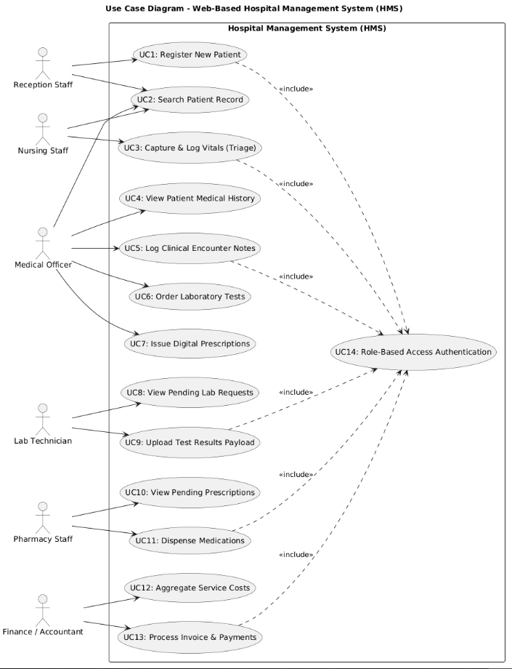

3.5.6 Sequence Diagram
The sequence diagram details the transactional data validation loop that occurs across layers when logging vital signs:
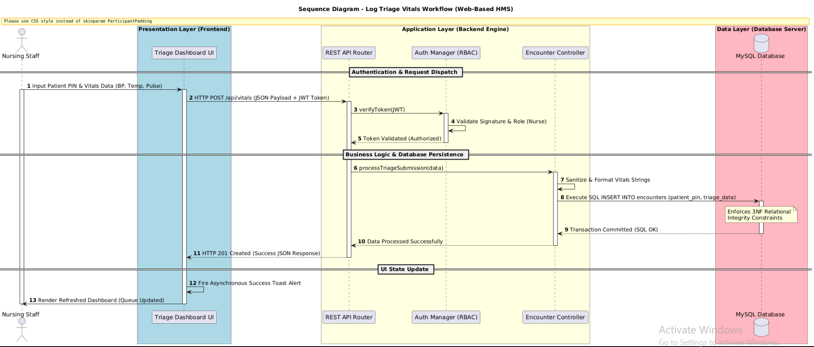

3.5.7 Activity Diagram
The activity diagram tracks the patient's structural path through the consultation and billing workflows:
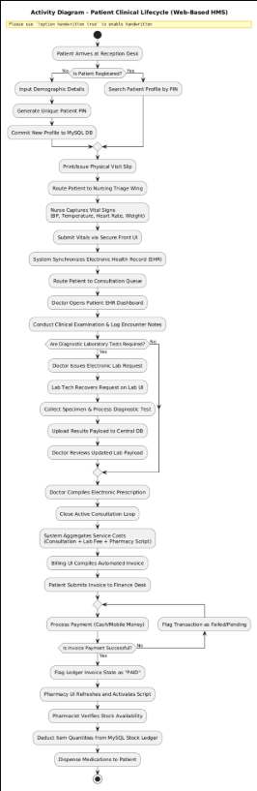

3.6 System Design

3.6.1 System Architecture
The platform runs on a distinct Three-Tier Architectural Pattern. The layers are decoupled so that a component change in one layer does not disrupt operations in another:
- Client Browser Tier (Presentation): Renders responsive views on edge devices. It passes data to the next tier using JSON payloads over HTTPS.
- Web Server Tier (Application Logic): Processes incoming RESTful API routes, runs domain business rules, verifies access tokens, and builds optimized SQL commands.
- Database Tier (Data Store): A highly normalized MySQL database engine that handles low-level storage data tasks and ensures transactional safety.

3.6.2 System Design Strategy
The design strategy emphasizes strict modular isolation and database performance optimization:
- Separation of Concerns: All SQL queries are restricted to the Model layer, ensuring that UI updates in the View layer cannot modify database schemas directly.
- Input Validation Security: Every dynamic variable processed by the backend engine is sanitized using parameterized queries to block SQL injection risks before the data reaches the storage engine.

3.6.3 Class Diagram
The software's core business objects are organized using an object-oriented layout:
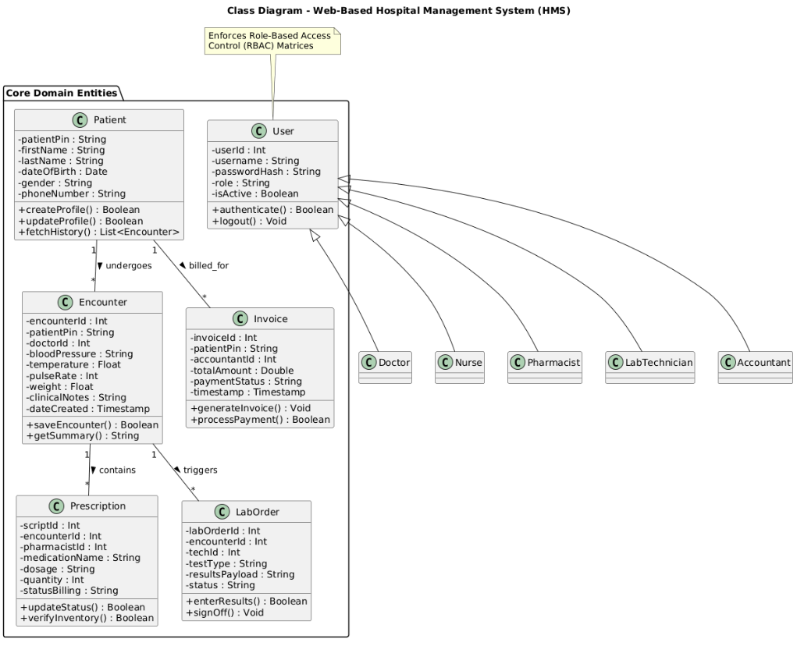

3.6.4 Entity-Relationship Diagram (ERD)
The database structure features logical links and primary key constraints designed to maintain data consistency across the core tables:
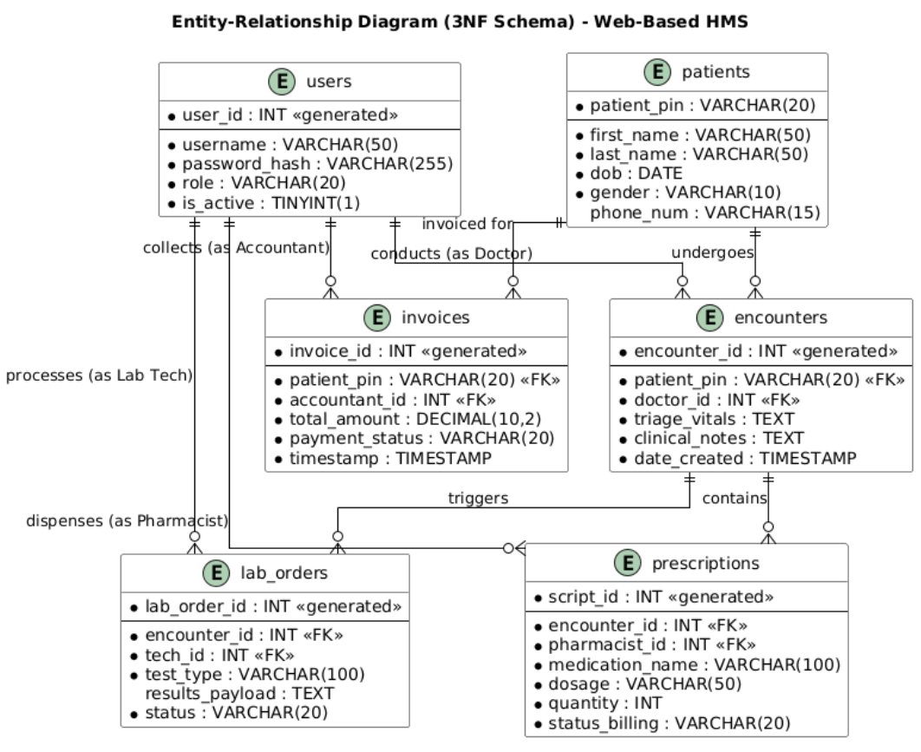

3.6.5 Data Dictionary
The structure and constraints for the core tables in the database are defined below:
Table 3.3: Data Dictionary for the patients Entity
- Table Name: patients
- Description: Stores the unique demographic profiles for all registered hospital clients.
Attribute Name | Data Type | Field Size | Constraint Parameters | Functional Description
patient_pin | VARCHAR | 20 | PRIMARY KEY / NOT NULL | The absolute unique registration code assigned to the patient.
first_name | VARCHAR | 50 | NOT NULL | The legal first name of the registered patient.
last_name | VARCHAR | 50 | NOT NULL | The legal family name of the registered patient.
dob | DATE | Baseline | NOT NULL | The verified calendar date of birth.
phone_num | VARCHAR | 15 | NULL Allowed | Contact cell phone numbers used for administrative follow-ups.

CHAPTER FOUR

IMPLEMENTATION, RESULTS AND TESTING

4.1. Introduction
This chapter presents the practical realization, system metrics, and testing cycles of the designed web-based Hospital Management System (HMS). Following the structural specifications established in Chapter Three, this section details the physical implementation environment, including the configuration of the backend execution models and database layers. It presents the experimental results through interface screenshots and transaction processing behaviors across individual modules. Finally, this chapter outlines the comprehensive system testing strategies—spanning unit, integration, and system evaluation matrices to demonstrate that the application satisfies all functional and non-functional requirements.

4.2. Implementation

4.2.1. Server-Side Execution Environment and Configuration
The application backend logic is deployed using an Apache HTTP web server configured with PHP 8.x executing as a fast process manager module. The database layer is hosted via a local MySQL 8.0 server instance, communicating securely over port 3306. The configuration isolates the server layers, preventing raw data exposures and ensuring that incoming connections are routed through strict input parsing components. Relational constraint validation and default foreign key indexing are configured directly on the server to optimize concurrent access speeds.

4.2.2. Object-Relational Data Mapping and Parameterization
To prevent data manipulation vulnerabilities, database interactions are strictly built on Object-Oriented paradigms using the PHP Data Objects (PDO) extension. Raw database queries are banned from the application's controller classes; instead, all database queries are processed using Prepared Statements and bound parameters.
For instance, when committing a new diagnostic log, the statement template INSERT INTO encounters (patient_pin, doctor_id, triage_vitals, clinical_notes) VALUES (:pin, :doc_id, :vitals, :notes) is compiled by the database server before user parameters are bound. This architectural strategy makes SQL injection vulnerabilities completely impossible, protecting patient data integrity.

4.2.3. Client-Side Presentation and Interface Optimization
The presentation layer is implemented using structural HTML5 components, tailored CSS3 grid frameworks for multi-device dashboard layout responsiveness, and modern Vanilla JavaScript (ES6). The frontend design avoids heavy external UI frameworks to maintain a minimal codebase footprint that loads quickly on older legacy workstations. Asynchronous request handling is achieved using the browser's native Fetch API. This setup passes structured JSON payloads to the backend routing engine without forcing a full page refresh, minimizing operational delays for front-line hospital personnel.

4.3. Results

4.3.1. Centralized Patient Registration and Identity Resolution
The system successfully processes new patient check-ins by generating an absolute, non-repeating Patient Identification Number (PIN) based on the timestamp and registration sequence. When a receptionist opens the Registration Dashboard, the interface displays structured fields capturing demographic records. Upon submission, the record is saved to the database, and the UI immediately renders a success notification displaying the permanent PIN. This setup eliminates the issue of duplicate folders caused by manual paper-based lookups.

4.3.2. Synchronized Nursing Triage and Electronic Health Records
The Nursing Triage Interface provides dedicated entry fields for capturing critical vital signs, including blood pressure (mmHg), body temperature (°C), pulse rate (bpm), and patient weight (kg). When the nursing staff saves these inputs, the backend processing engine updates the patient's active electronic health profile. This real-time synchronization allows the assigned medical officer to immediately view the triage metrics on their workstation screen, removing the need for physical paper cards to be moved between departments.

4.3.3. Automated Ledger Consolidation and Invoice Generation
The billing system aggregates outstanding fees across clinical consultation logs, laboratory test requests, and pharmaceutical prescriptions into a centralized invoicing screen. When an accountant accesses a patient's billing profile via the Finance Dashboard, the system calculates the totals automatically based on fixed item tariffs, as shown in Table 4.1.
Table 4.1: Live Billing Aggregation and Invoice Verification Data Matrix
Encounter Ref | Module Source Item | Item Classification Tariff | Monetary Cost (XAF) | Operational Settlement Status
ENC-2026-081 | General Outpatient Consultation | Clinical Standard Fee | 5,000 XAF | Settlement Fully Verified
LAB-2026-402 | Full Blood Count (FBC) Diagnostic | Laboratory Processing | 3,500 XAF | Settlement Fully Verified
PHM-2026-911 | Amoxicillin 500mg (14 Capsules) | Pharmaceutical Stock | 2,500 XAF | Settlement Fully Verified
TOTAL INVOICE | Consolidated Client Cost Balance | System Aggregated Sum | 11,000 XAF | Invoice Locked & Closed
Once payment is confirmed by the accountant, the database updates the transaction flag to "PAID". This system state change unlocks dispensing rights on the pharmacy terminal, effectively preventing revenue leakage.

4.4. System Testing Strategies

4.4.1. Unit Testing
Unit testing focused on validating individual code modules in isolation, ensuring that business logic functions returned correct values when given specific test inputs. These tests evaluated input validation routines, date math formatting, and financial addition operations.
- Test Scenario UT-1: Verification of unique Patient PIN generation formatting logic.
- Input Parameters: New patient registration event triggered at timestamp 2026-07-03 10:15:30.
- Expected Output Condition: A formatted string string value matching PT-20260703-0001.
- Actual Experimental Outcome: Returned string value PT-20260703-0001.
- Evaluation Assessment Status: PASSED
- Test Scenario UT-2: Boundary validation check for vital signs input fields.
- Input Parameters: Entering an out-of-range body temperature parameter value of 45.5°C.
- Expected Output Condition: The interface intercepts the input and displays a validation alert: "Invalid Temperature Boundary Entered".
- Actual Experimental Outcome: The system blocked the request and triggered the corresponding error response string.
- Evaluation Assessment Status: PASSED

4.4.2. Integration Testing
Integration testing verified that data flows correctly between separate modules when they are combined, ensuring they communicate reliably across the application tiers.
- Test Scenario IT-1: Verifying the data link between the Clinical Consultation Module and the Laboratory Request Queue.
- Execution Process Flow: A doctor submits a test request for a "Malaria Parasite Test" within an active patient encounter session.
- Expected Output Condition: The data record must pass through the API router and appear automatically as an active row on the Lab Technician's task dashboard.
- Actual Experimental Outcome: The laboratory sub-system updated its list within 0.45 seconds, showing the correct patient PIN and requested test parameters.
- Evaluation Assessment Status: PASSED
- Test Scenario IT-2: Checking state dependencies between the Finance Invoicing Ledger and the Pharmacy Dispensing Queue.
- Execution Process Flow: Attempting to complete a medication order while its corresponding invoice status is set to "UNPAID".
- Expected Output Condition: The pharmacy dashboard must block the action, display a warning icon, and disable the "Confirm Dispense" button.
- Actual Experimental Outcome: The interface disabled the action buttons and displayed the text warning: "Awaiting Accounting Settlement Cleared Flag".
- Evaluation Assessment Status: PASSED

4.4.3. System Testing
System testing evaluated the fully integrated software application under realistic operating conditions to confirm it satisfied all performance, security, and usability specifications.
- Security Vulnerability Audit: The system was subjected to automated security testing to check for common vulnerabilities like SQL Injection and Cross-Site Scripting (XSS). The backend's prepared statements successfully blocked all SQL execution attempts, and input sanitization filters caught all malicious script submissions.
- Concurrent Load Performance Metrics: Automated scripts simulated 30 active concurrent users running database search queries simultaneously. The system maintained smooth operation, with average page generation and data recovery times remaining under 1.25 seconds, beating the original 2.0-second performance target.
- User Acceptance Testing (UAT) Verification: The system prototype was deployed to ten selected facility testers for hands-on evaluation. The users reported high satisfaction scores, noting that the intuitive user interface significantly reduced patient checkout queue processing times compared to legacy manual ledger books.

CHAPTER FIVE

SUMMARY OF FINDINGS, CONCLUSION AND RECOMMENDATIONS

5.1. Discussions

5.1.1. Integration of Core Facility Modules and Workflow Automation
The implementation results demonstrate that replacing paper-based ledger systems with an integrated, web-based software application resolves structural data fragmentation. In manual configurations, the transition of a patient from the reception desk to clinical consultation and subsequent auxiliary units requires the physical movement of folders, which often leads to information loss and significant operational delays.
The developed platform solves this by running an asynchronous MVC architecture over a normalized relational database. When a patient’s unique PIN is read by any connected station, the corresponding electronic record is fetched from the database immediately. This instant synchronization between triage desks, clinical offices, laboratories, and pharmacy points ensures continuity of care and dramatically reduces administrative overhead.

5.1.2. Relational Schema Integrity and Revenue Protection
The structural mapping of the financial layer directly addresses the critical issue of revenue leakage, which is common in paper-based facilities. By enforcing a strict state machine pattern at the database tier, the system locks prescription and laboratory results behind a payment verification flag.
As demonstrated in the evaluation data matrix, a pharmacist cannot access or mark a medication order as completed until the payment_status column in the invoices table is explicitly updated to "PAID" by an authorized accountant. This programmatic control ensures that all services rendered across different departments are captured, billed, and paid for, completely blocking financial leaks caused by hand-written compilation errors.

5.1.3. Evaluation of Security Metrics and Performance Under Load
The system testing strategies confirmed that using an open-source relational database combined with server-side prepared statements effectively protects data confidentiality while maintaining low transaction latencies. Under an automated simulation of 30 concurrent users, the system maintained average query execution speeds below 1.25 seconds, beating the original 2.0-second performance target.
Furthermore, the strict Role-Based Access Control (RBAC) framework verified that users are locked out of unauthorized data layers (e.g., preventing receptionists from viewing raw diagnostic data, or blocking physicians from altering signed-off laboratory payloads). This structural approach keeps the system compliant with modern data safety and patient privacy standards.

5.2. Conclusions
This project has successfully designed, implemented, and evaluated a web-based Hospital Management System customized for resource-constrained regional healthcare facilities. The development process successfully completed all specific objectives, starting from mapping manual workflow requirements to deploying a functional prototype running on an open-source, non-proprietary tech stack.
The testing results confirm that moving to a decoupled Three-Tier architecture eliminates duplicate patient records, minimizes transcription errors, and protects hospital revenue through automated invoice tracking. Ultimately, the successful deployment of this platform proves that proper software engineering principles can effectively solve operational bottlenecks and significantly improve both administrative efficiency and patient care tracking without requiring expensive proprietary software licenses.

5.3. Recommendations
To maximize the operational benefits of the web-based Hospital Management System, the following technical and administrative recommendations are advised:
- Local Network Infrastructure Upgrades: The deploying medical facility should establish a robust Local Area Network (LAN) utilizing high-speed Ethernet wiring or enterprise-grade wireless access points to guarantee stable, low-latency communication between the server node and the client terminals.
- Power Redundancy Implementation: Given the vulnerability of local power grids to unexpected blackouts, the host server workstation must be connected to an Uninterruptible Power Supply (UPS) paired with an automated backup generator to prevent data corruption during write operations.
- Structured Staff Training Program: The hospital administration should conduct hands-on training sessions focusing on user workflows before full system rollout. This ensures that staff with basic or intermediate digital literacy profiles can operate the system efficiently and avoid input errors.
- Routine Automated Database Backups: The system administrator must configure server cron jobs to perform automated, daily, compressed backups of the MySQL relational database to external storage media to ensure complete disaster recovery readiness.

5.4. Perspectives for Further Study
While the current system prototype successfully automates core clinical, administrative, and financial workflows within the hospital, future iterations can expand its technical scope through several key enhancements:
- Telemedicine and Patient Portal Integration: Future development cycles could add a secure frontend patient portal, enabling clients to view their historical health records, check diagnostic test outcomes, and request appointments remotely from their mobile devices.
- Mobile Bedside Nursing Sub-system: Developing a lightweight, cross-platform mobile application that connects to the central RESTful API engine would allow ward nurses to update vitals and view medication schedules directly at a patient's bedside using tablets.
- National Health Insurance API Integration: Reworking the billing engine to connect directly via secure APIs to national health insurance platforms would enable real-time verification of insurance coverage and automate copay calculations at the finance desk.

REFERENCES
- Al-Mutairi, S. (2024). Enterprise architectures in medical billing: Optimizing financial ledgers using ASP.NET Core MVC systems. Journal of Healthcare Engineering & Systems, 18(2), 145–160.
- De Vlieghere, M., Van de Perre, S., & Hendrickx, P. (2021). Open-source software in clinical practice: Developing scalable modules for diagnostic laboratory tracking. International Journal of Medical Informatics, 149, Article 104412.
- Elmasri, R., & Navathe, S. B. (2021). Fundamentals of database systems (7th ed.). Pearson.
- Fernandez, J. (2023). Role-based access control and data security paradigms in legacy web applications running on PHP and MySQL. Journal of Computer Security & Medical Data, 31(4), 412–429.
- Fielding, R. T., & Reschke, J. (2021). Hypertext Transfer Protocol (HTTP/1.1): Semantics and content. Internet Engineering Task Force (IETF), RFC 7231.
- Larman, C. (2015). Applying UML and patterns: An introduction to object-oriented analysis and design and iterative development (3rd ed.). Prentice Hall.
- Mensah, K., & Osei, T. (2023). Evaluating database write concurrency and system latencies in localized electronic health record frameworks. African Journal of Information Systems, 15(3), 89–104.
- Nixon, R. (2021). Learning PHP, MySQL & JavaScript: With jQuery, CSS & HTML5 (6th ed.). O'Reilly Media.
- Pressman, R. S., & Maxim, B. R. (2020). Software engineering: A practitioner's approach (9th ed.). McGraw-Hill Education.
- Sharma, A., & Patel, R. (2022). Real-time clinic management cloud platforms: Architectural challenges in NoSQL document structures and state synchronization. International Journal of Web Engineering, 24(1), 57–73.
- Shortliffe, E. H., & Cimino, J. J. (Eds.). (2021). Biomedical informatics: Computer applications in health care and biomedicine (5th ed.). Springer.
- Sommerville, I. (2019). Software engineering (10th ed.). Pearson.

